Sunday, October 30, 2022

Worship 11:00am – Reformation Sunday

Welcome & Announcements

Praise & Worship

Children’s Message
Scripture: Luke 19:1-10 Spark Bible

Offering & Song

Prayer & Lord’s Prayer

Worship Song

Scripture: John 8:31-36 NRSV

Message

Sending Song

Blessing
- Worship services are intended to welcome children and their families into time with God. Children are welcome to stay with parents for worship.

- Power Zone (Sunday School) – PowerZone will be gather in
classroom A after children’s message.
- Today’s story is “Jesus and Zacchaeus”

- Prayer Support: Requests for prayer or pastoral needs can be made in confidence via email: prayer@makingfaithmatter.ca

October’s PowerZone has not been sponsored

October’s hospitality has not been sponsored

October’s music has not been sponsored

October’s
bulletin has been sponsored by Kiung Ahn in celebration of his birthday.

#MakingFaithMatter
Ladies’ Coffee Connection
Coffee, chat and a chance to reconnect!
Thursday, November 3rd 9:30 – 11:00am
First Lutheran Sanctuary

It’s daylight savings time next week! Remember to turn your clocks back one hour

For the month of November until our Children’s Christmas pageant December 11th we will be collecting gently used toys,
NO
stuffed animals please,
for children in the
Calgary Foster system.
These items are for children of all ages. Cash donations or gift cards are also appreciated for batteries or items that will complete a gift.
This organization operates under the umbrella of the
Calgary Foster Parents Association

It is time to renew your Canada Lutheran Magazine. Subscriptions must be received by October 31st if you want to renew or start receiving this terrific magazine. We have a discounted rate of $18.11 for a year. Make cheques payable to First Lutheran Church. For more information please see Liz.

It is time to renew your Canada Lutheran Magazine. Subscriptions must be received by October 31st if you want to renew or start receiving this terrific magazine. We have a discounted rate of $18.11 for a year. Make cheques payable to First Lutheran Church. For more information please see Liz.

New member Sunday will be held on Sunday November 27th. If you would like to become a member of First Lutheran Church please contact Pastor Kevin.

This year’s AGM will be held Sunday November 27th.

If you would like to be added to the Sunday prayers or be put on our prayer chain please fill out the prayer request card by the sound booth and put it in the offering plate or give it to a staff member.
It’s time to renew your Lutheran Magazine subscription for $19.49!

Talk to Kelly if you’d like to renew or sign up for this great magazine

Bottle and can collection is ongoing.
Please drop your bottles off by the
shed closest to the garbage bin.
Your support is appreciated!
$1,082.05 was collected in 2021.
Have you remembered the church in your Will?
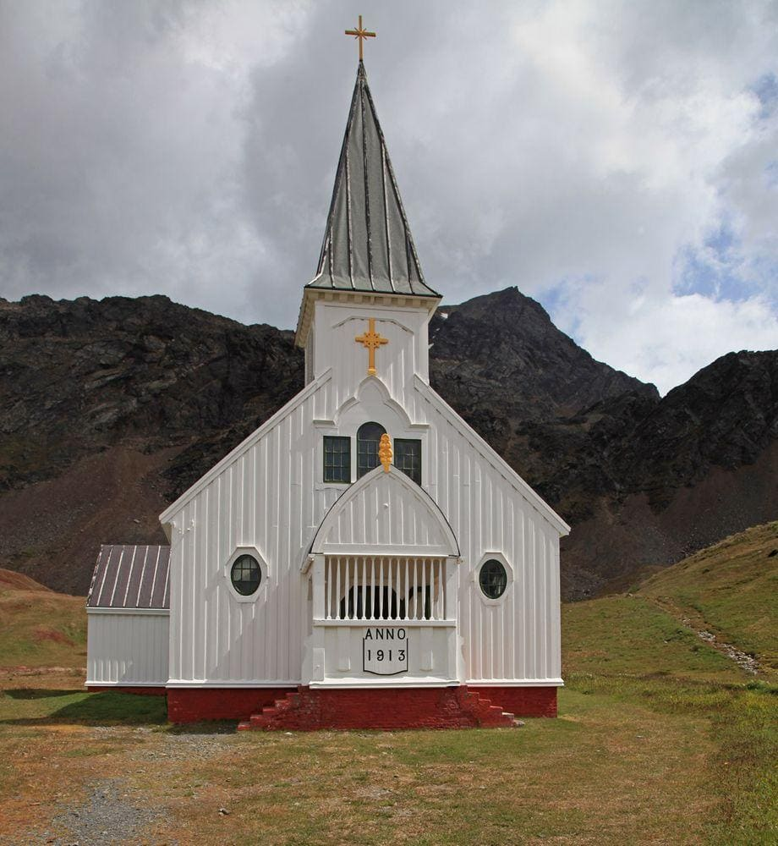

First Lutheran’s Vision Statement.
First Lutheran Church is a dynamic
Christian community that is making faith matter
in a constantly changing world.

Facebook.com/FirstLutheranChurchCalgary
@FLCCalgary
Youtube.com/FirstLuthCalgary
FLCCalgary

Visit us online at www.makingfaithmatter.ca

Want to contact us?
Office Hours: Monday – Wednesday, 10am-3pm
Office Phone 403-242-4544

Kevin – Pastor: Local 206 Cell: 587-890-9759
kevin@makingfaithmatter.ca

Kelly – Financial Assistant & Property Manager: Local 207
Christmas Eve Candlelight Services
December 24th
at 3, 5 and 7pm.
Communion will
be served at all
three services.

All are welcome.
kelly@makingfaithmatter.ca
Christmas Eve Candlelight Services
December 24th
at 3, 5 and 7pm.
Communion will
be served at all
three services.

All are welcome.

Yvonne – Worship Director: Local 202
worship@makingfaithmatter.ca

First Lutheran Church
7102 – 14th Avenue SW
Calgary, Alberta T3H 4G7
Tel: 403-242-4544
www.makingfaithmatter.ca

