Sunday, October 23, 2022

Worship 11:00am – Pentecost 20

Welcome & Announcements

Praise & Worship

Children’s Message
Scripture: Luke 18:9-14 Spark Bible

Offering & Song

Prayer & Lord’s Prayer

Worship Song

Scripture: 2Peter 1:1-9 LB

Message

Sending Song

Blessing
- Worship services are intended to welcome children and their families into time with God. Children are welcome to stay with parents for worship.

- Power Zone (Sunday School) – PowerZone will be gather in
classroom A after children’s message.
- Today’s story is “The Pharisee and the Tax Collector”

- Prayer Support: Requests for prayer or pastoral needs can be made in confidence via email: prayer@makingfaithmatter.ca

October’s PowerZone has not been sponsored

October’s hospitality has not been sponsored

October’s music has not been sponsored

October’s
bulletin has been sponsored by Kiung Ahn in celebration of his birthday.

#MakingFaithMatter
We are in need of council members!
Please consider joining council and helping First Lutheran discern the work that God is calling us to do
Join us today, October 23rd, for Feast & Fellowship in the gym after service.
Bring your favourite potluck item and take the opportunity to
connect with others.

It is time to renew your Canada Lutheran Magazine. Subscriptions must be received by October 31st if you want to renew or start receiving this terrific magazine. We have a discounted rate of $18.11 for a year. Make cheques payable to First Lutheran Church. For more information please see Liz.

It’s time to renew your Lutheran Magazine subscription for $19.49!

Talk to Kelly if you’d like to renew or sign up for this great magazine
.
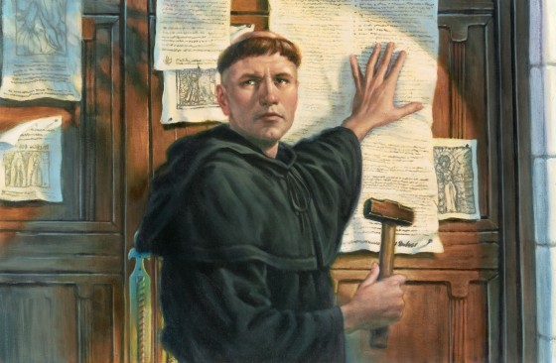

It is time to renew your Canada Lutheran Magazine. Subscriptions must be received by October 31st if you want to renew or start receiving this terrific magazine. We have a discounted rate of $18.11 for a year. Make cheques payable to First Lutheran Church. For more information please see Liz.

Pub Night is back!
Join us today October 23rd from
5:30 – 7:00 at the Dorset
(37th street & 17th avenue,
formerly Donegal’s)

If you would like to receive
our weekly emails from
Pastor Kevin please email
kevin@makingfaithmatter.ca

If you would like to be added to the Sunday prayers or be put on our prayer chain please fill out the prayer request card by the sound booth and put it in the offering plate or give it to a staff member.

Have you remembered the church in your Will?
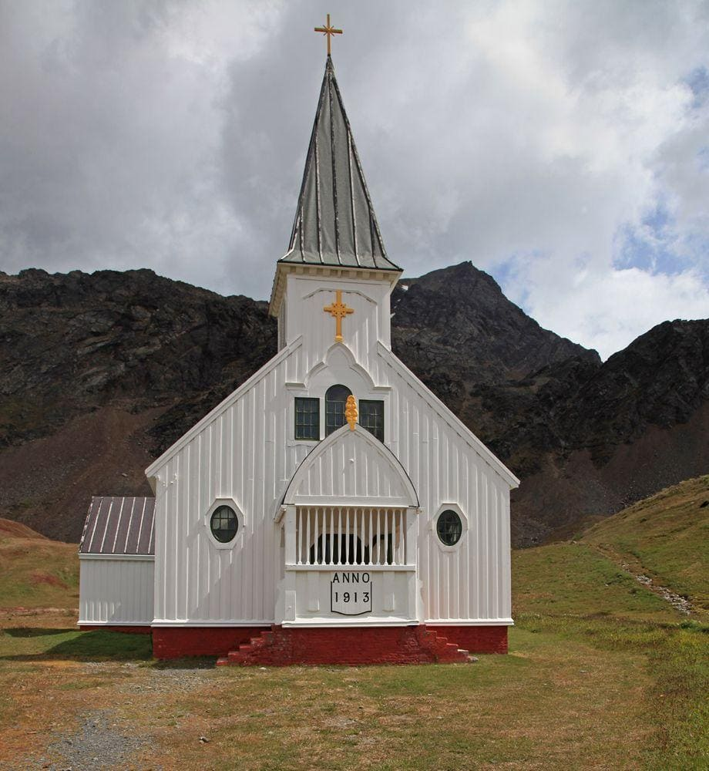
Bottle and can collection is ongoing.
Please drop your bottles off by the
shed closest to the garbage bin.
Your support is appreciated!
$1,082.05 was collected in 2021.

First Lutheran’s Vision Statement.
First Lutheran Church is a dynamic
Christian community that is making faith matter
in a constantly changing world.

Facebook.com/FirstLutheranChurchCalgary
@FLCCalgary
Youtube.com/FirstLuthCalgary
FLCCalgary

Visit us online at www.makingfaithmatter.ca

Want to contact us?
Office Hours: Monday – Wednesday, 10am-3pm
Office Phone 403-242-4544

Kevin – Pastor: Local 206 Cell: 587-890-9759
kevin@makingfaithmatter.ca

Kelly – Financial Assistant & Property Manager: Local 207
Christmas Eve Candlelight Services
December 24th
at 3, 5 and 7pm.
Communion will
be served at all
three services.

All are welcome.
kelly@makingfaithmatter.ca
Christmas Eve Candlelight Services
December 24th
at 3, 5 and 7pm.
Communion will
be served at all
three services.

All are welcome.

Yvonne – Worship Director: Local 202
worship@makingfaithmatter.ca

First Lutheran Church
7102 – 14th Avenue SW
Calgary, Alberta T3H 4G7
Tel: 403-242-4544
www.makingfaithmatter.ca

