Sunday, March 5, 2023

Worship 11:00am – Lent 2

Welcome & Announcements

Praise & Worship

Children’s Message
Scripture: John 3:1-17 Spark Bible

Offering & Song

Prayers

Scripture: John 3:1-17 NRSV

Message

Lord’s Prayer

Holy Communion

Sending Song

Blessing
- Worship services are intended to welcome children and their families into time with God. Children are welcome to stay with parents for worship.

- Power Zone (Sunday School) – PowerZone will be meeting in classroom A today.
- Today’s story is “A Secret Meeting”

- Prayer Support: Requests for prayer or pastoral needs can be made in confidence via email: prayer@makingfaithmatter.ca

February’s hospitality has been sponsored by Ken & Sharon

February’s PowerZone has not been sponsored

March’s
bulletin has been sponsored by

a caring person

March’s music has been sponsored by Kelly & Tim in celebration of Kelly’s birthday

#MakingFaithMatter

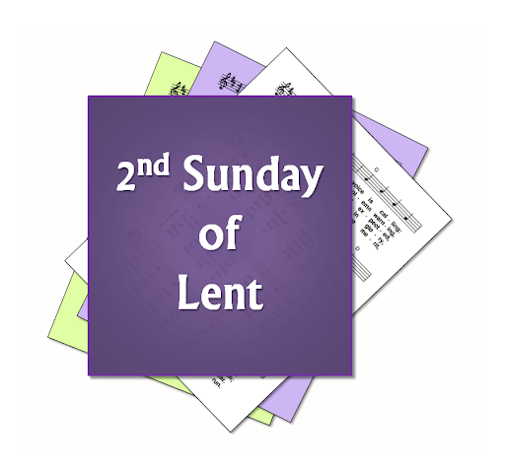
Ladies Coffee Connect will now be on Friday’s!

Join Yvonne on the on the first Friday of each month and connect with others.
The next Coffee Connect is Friday, March 31st.

It is time to renew your Canada Lutheran Magazine. Subscriptions must be received by October 31st if you want to renew or start receiving this terrific magazine. We have a discounted rate of $18.11 for a year. Make cheques payable to First Lutheran Church. For more information please see Liz.

It is time to renew your Canada Lutheran Magazine. Subscriptions must be received by October 31st if you want to renew or start receiving this terrific magazine. We have a discounted rate of $18.11 for a year. Make cheques payable to First Lutheran Church. For more information please see Liz.

Join us for our next Soup Social Thursday, March 16th
at noon in the Sanctuary.
Please sign up or R.S.V.P. to Kelly @ 403-242-4544

Consider sponsoring the bulletin, hospitality, music or PowerZone for a special occasion or “just because”.
Sponsor sheets are on the bulletin board in the lobby under the clock.

Daylight Savings March 12
Clocks “spring” forward one hour

Have you remembered the church in your Will?
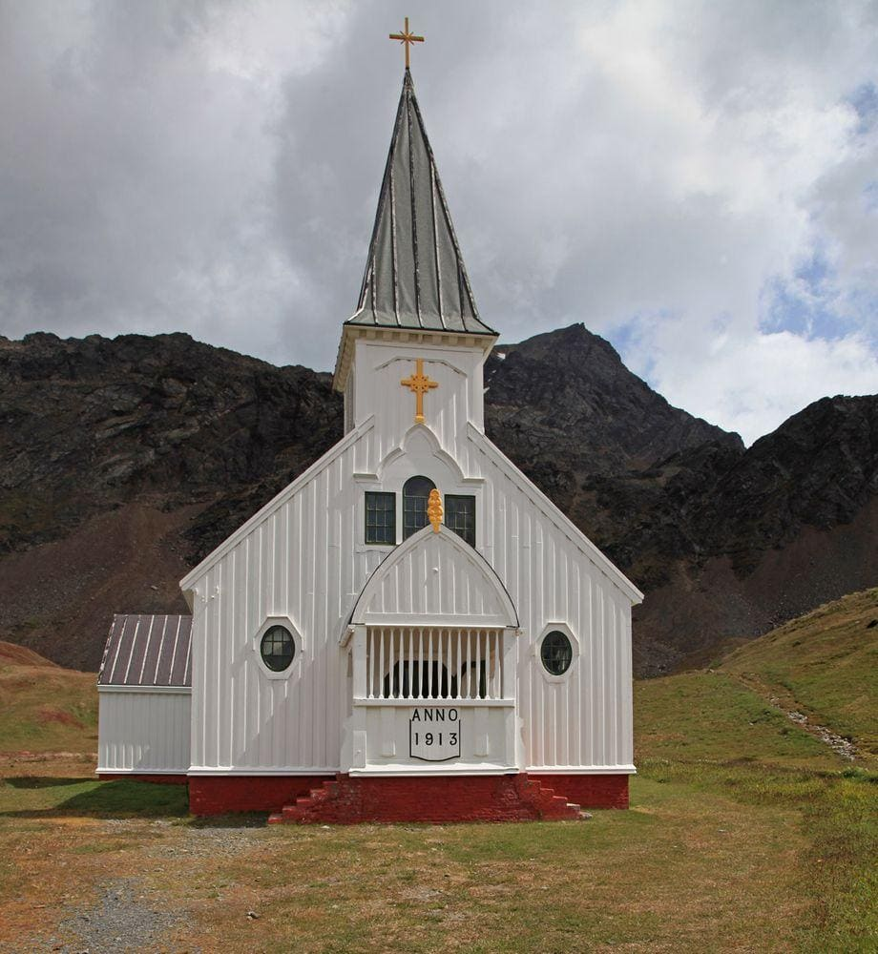
Bottle and can collection is ongoing.
Please drop your bottles off by the
shed closest to the garbage bin.
Your support is appreciated!
$1,125.30 was collected in 2022.

First Lutheran’s Vision Statement.
First Lutheran Church is a dynamic
Christian community that is making faith matter
in a constantly changing world.

Facebook.com/FirstLutheranChurchCalgary
@FLCCalgary
Youtube.com/FirstLuthCalgary
FLCCalgary

Visit us online at www.makingfaithmatter.ca

Want to contact us?
Office Hours: Monday – Wednesday, 10am-3pm
Office Phone 403-242-4544

Kevin – Pastor: Local 206 Cell: 587-890-9759
kevin@makingfaithmatter.ca

Kelly – Financial Assistant & Property Manager: Local 207
Christmas Eve Candlelight Services
December 24th
at 3, 5 and 7pm.
Communion will
be served at all
three services.

All are welcome.
kelly@makingfaithmatter.ca
Christmas Eve Candlelight Services
December 24th
at 3, 5 and 7pm.
Communion will
be served at all
three services.

All are welcome.

Yvonne – Worship Director: Local 202
worship@makingfaithmatter.ca

First Lutheran Church
7102 – 14th Avenue SW
Calgary, Alberta T3H 4G7
Tel: 403-242-4544
www.makingfaithmatter.ca

